**Watari – Wireframe Discussion Points**

The Low-fidelity wireframes created by Steven presents a well-conceived layout. I support starting here, and filling and shaping as we go along. Here are a few suggestions on the design aspects of some of the sections.

Homepage

Here are my proposed changes to the Navigation bar headings:

|  |  |  |
| --- | --- | --- |
|  | Current navigation headings | Redesign navigation headings |
|  |  |  |
| 1. | Home | **Home** |
| 2. | Who We Are | **About Us** |
| 3. | Services | **Our Work** |
| 4. | Watari’s Impact | Should be amalgamated with Our Work content |
| 5. | Donate | **Donate** |
| 6. | Our Partners | **Partners** |
| 7. | Contact Us | **Contact Us** |
| 8. | Like Us On Facebook | remove heading and convert to social media icon |
| 9. | Join Us on Twitter | remove heading and convert to social media icon |
| 10. | Survival Manual | **Support or Find Help** |
| 11. | Board Login | remove heading and create a **Login** link to another page that allows Board and EGT2 members tologin in |
| 12. | EGT2 Login | remove heading and create a **Login** link to another page that allows Board and EGT2 members tologin. |

* I like Steven’s idea of keeping the top portion of the homepage clean with just a hero, a caption in the middle (Facilitating positive change in our community), and CTA (Donate).
* Here is a page I though presented something like what is being floated. I would change the actual $ amounts to just a Donate link.

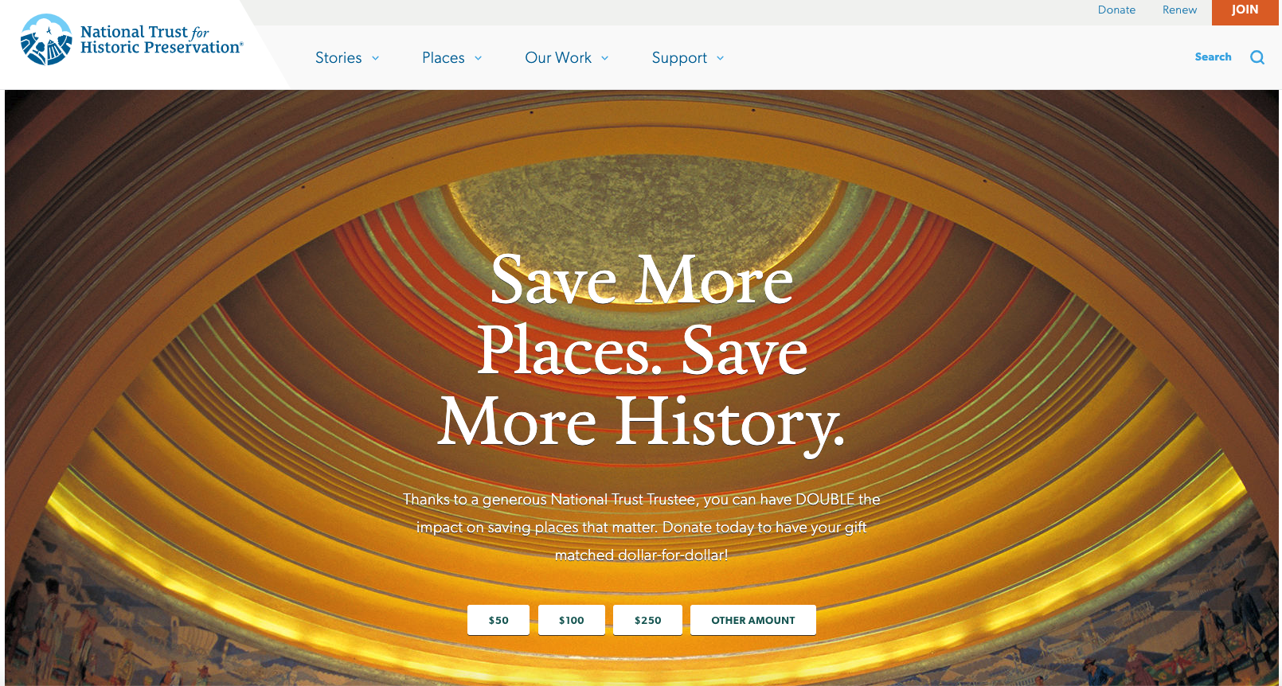

About Us Page

This is an interesting way to present the organization’s core values, and what motives them. It’s not the right color scheme but the layout of the content is impactful.

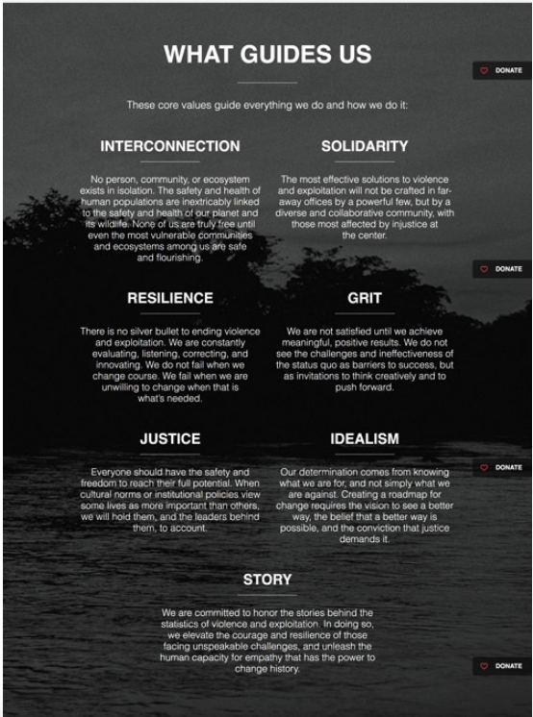

In the About Us page we could also present the team members of the organization:

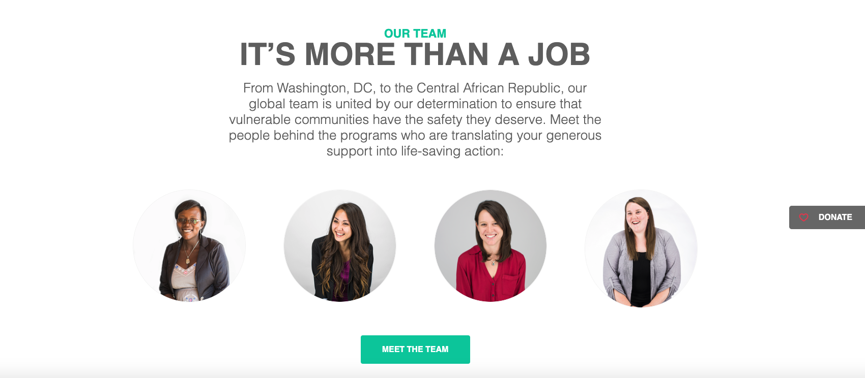

Donation Page

I like the simplicity and design of this Donation Page.

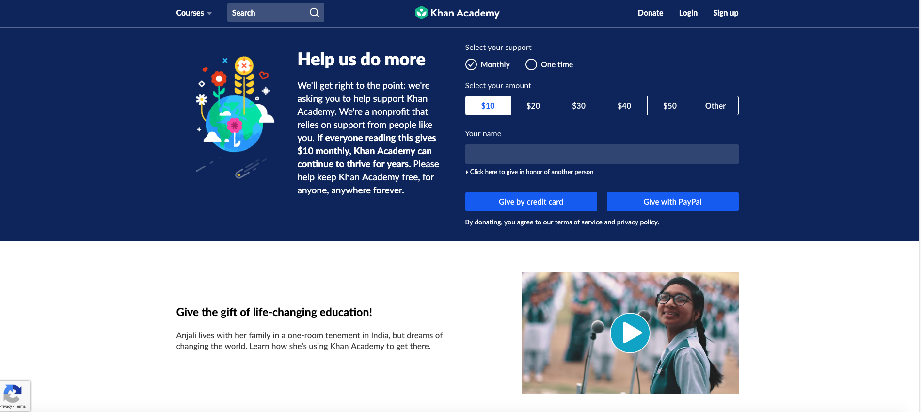

I also though the idea of a stationary Donate tag like the one presented on this website: <https://invisiblechildren.com/> was interesting. Is it a bit too aggressive?

Blog/News Page

I like the way information is presented on this page, especially the calendar tool.

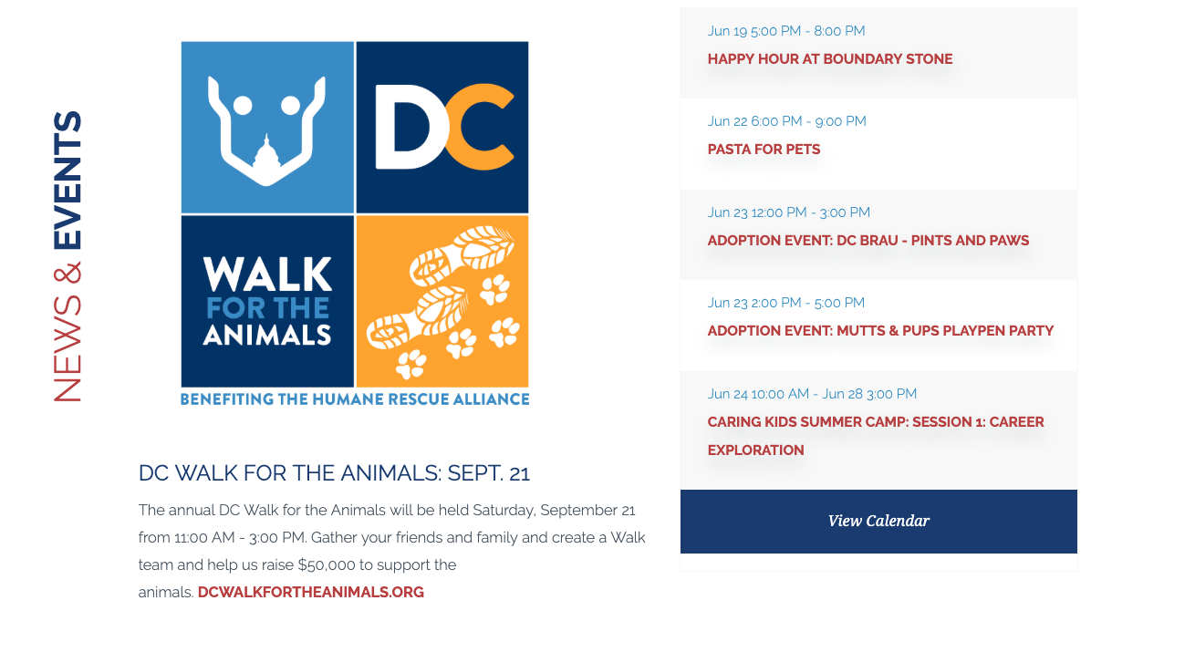

What are our next steps, Prototyping?

1. Using a mock-up tool (like InVision) to create a prototype website of the wireframes.
2. Solicit users to test the prototype and collect feedback.